**EXP-2:**

**Build a responsive banking UI with deposit/withdrawal buttons and balance display:**

<!DOCTYPE html>

<html lang="en">

<head>

<meta charset="UTF-8" />

<title>Bank UI</title>

<meta name="viewport" content="width=device-width, initial-scale=1.0"/>

<style>

body { font-family: sans-serif; background: #eaeef1; }

.bank-container {

max-width: 400px;

background: #fff;

margin: 3rem auto;

border-radius: 10px;

box-shadow: 0 2px 10px #0002;

padding: 2rem;

text-align: center;

}

.balance { font-size: 2rem; margin: 1rem 0; color: #3560f6; }

.btns input[type="number"] { width: 100px; margin-right: 1rem; }

.deposit, .withdraw {

background: #3560f6;

color: #fff; border: none; border-radius: 5px; padding: 8px 14px;

margin: 0.5rem;

cursor: pointer;

}

.withdraw { background: #f66c4f; }

@media (max-width: 520px) {

.bank-container { padding: 1rem; }

.btns { display: block; }

.btns > * { margin: 0.25rem auto; }

}

</style>

</head>

<body>

<div class="bank-container">

<h2>Your Account</h2>

<div class="balance" id="balance">$0.00</div>

<div class="btns">

<input type="number" id="amount" placeholder="Amount" min="1"/>

<button class="deposit" onclick="deposit()">Deposit</button>

<button class="withdraw" onclick="withdraw()">Withdraw</button>

</div>

<div id="message" style="margin-top: 1rem; color: #d64f3a;"></div>

</div>

<script>

let balance = 0;

function updateBalance() {

document.getElementById('balance').innerText = `$${balance.toFixed(2)}`;

}

function showMsg(msg, color) {

const msgDiv = document.getElementById('message');

msgDiv.style.color = color;

msgDiv.innerText = msg;

setTimeout(()=>msgDiv.innerText='',2000);

}

function deposit() {

let amt = Number(document.getElementById('amount').value);

if(amt > 0) {

balance += amt;

updateBalance();

showMsg('Deposit Successful', '#36ad6e');

} else {

showMsg('Enter a valid amount.', '#d64f3a');

}

document.getElementById('amount').value = '';

}

function withdraw() {

let amt = Number(document.getElementById('amount').value);

if(amt > 0 && amt <= balance) {

balance -= amt;

updateBalance();

showMsg('Withdrawal Successful', '#36ad6e');

} else if(amt > balance) {

showMsg('Insufficient funds.', '#d64f3a');

} else {

showMsg('Enter a valid amount.', '#d64f3a');

}

document.getElementById('amount').value = '';

}

updateBalance();

</script>

</body>

</html>

**OUTPUTS:**

**Task-2:**

**Basic Interface:**

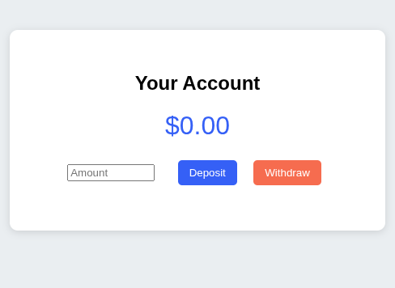

**Money Deposited:**

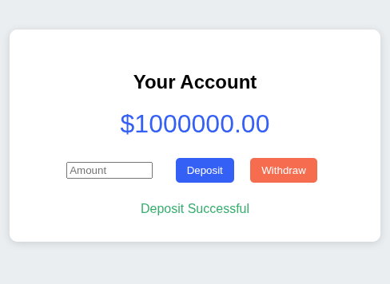

**Money Withdrawal:**

